PRODUCT QUALITY MANUAL: MAIN TILE

|  |  |
| --- | --- |
| **PRODUCT SPECIFICATION:** |  |
| **Title: DOUBLE ROMAN PLUS – OLIFANTSFONTEIN** | **Reference 4.4.1** |

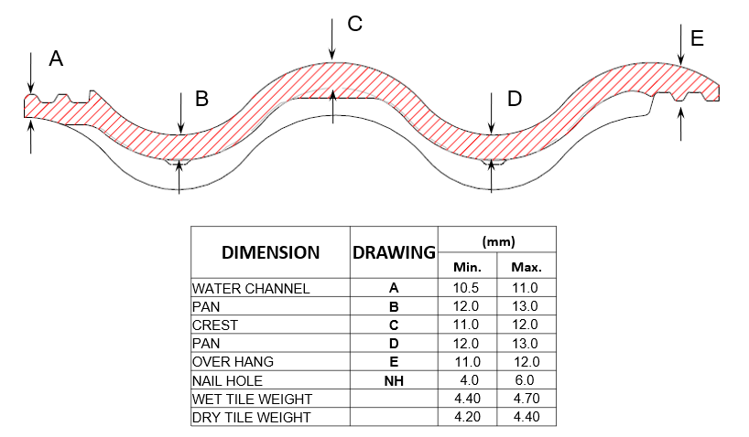

Page 1 of 4 Issue date 01 -01-2020 Issue Number: 01 Approved By: